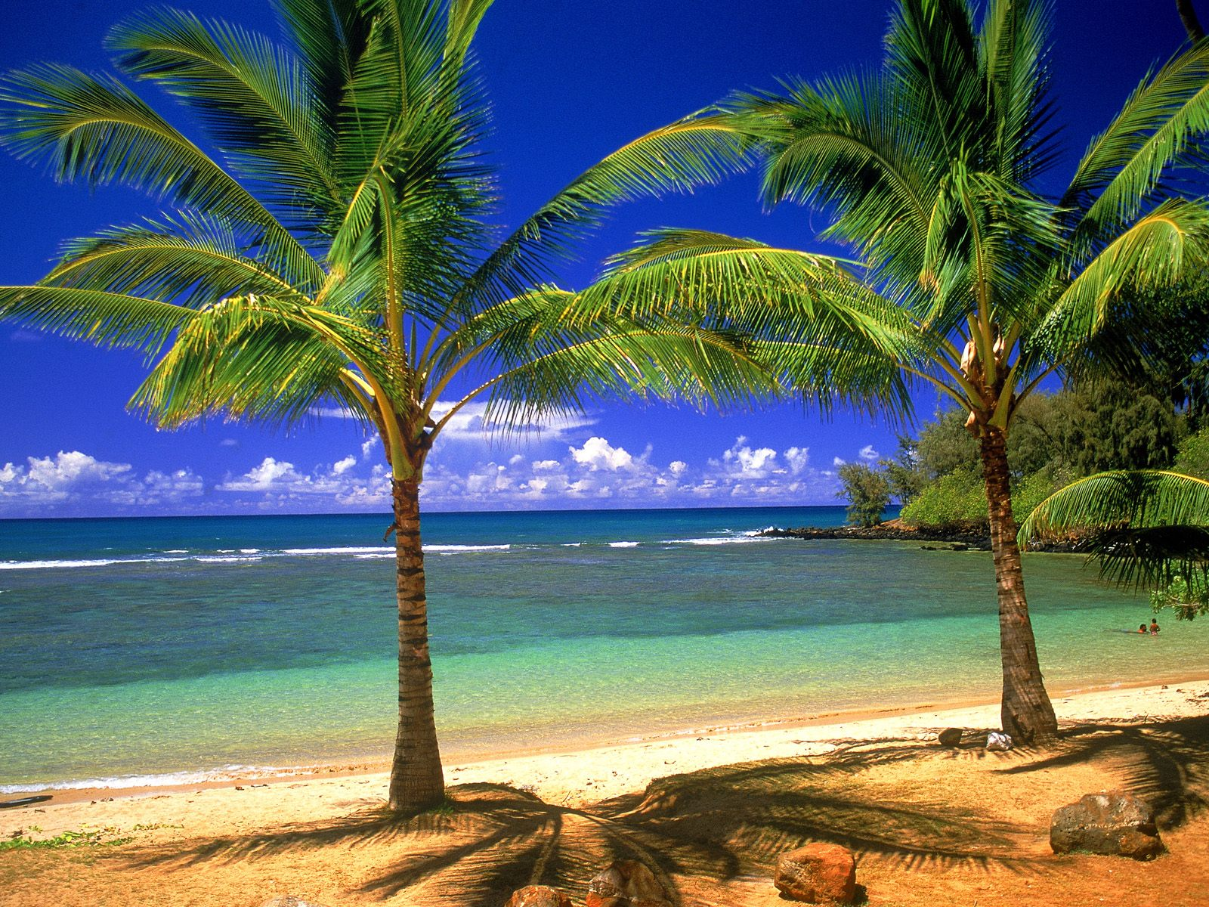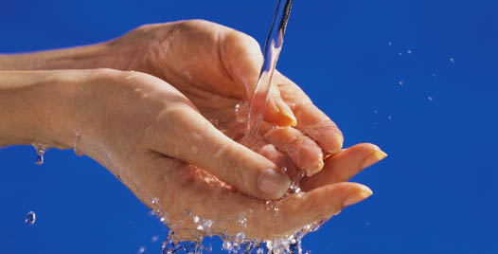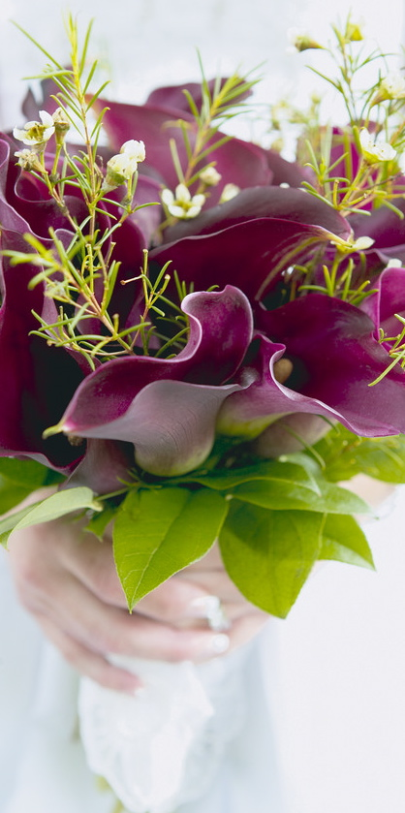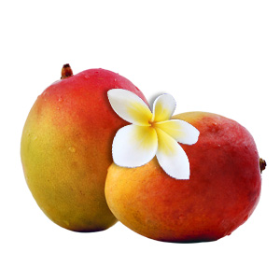

Works Cited

"Point of Interest!" *: Formulating for Your Skin Type: Sugar Scrub for Dry Skin*. Web. 01 June 2012. <http://swiftcraftymonkey.blogspot.com/2010/04/formulating-for-your-skin-type-sugar.html>.

Sherwood, Chris. "How Does Perfume Work?" *EHow*. Demand Media, 28 Oct. 2008. Web. 01 June 2012. <http://www.ehow.com/how-does_4567999_perfume-work.html>.

"Sugar Scrub." *Expand Your Knowledge Base*. Web. 01 June 2012. <http://topics.info.com/Sugar-Scrub_4293>.

"What Doesn't Mix with Oil and Water?" *Yahoo! Answers*. Yahoo! Web. 01 June 2012. <http://answers.yahoo.com/question/index?qid=20080503113850AAnsyG4>.

Sugar scrubs are very beneficial to exfoliating and moisturizing your skin.  They each have three types of ingredients.  The first is, in our case, sugar.  The sugar exfoliates and removes dead skin cells to reveal the layer of new skin.  The oil in the mixture is used to hold the mixture together and to moisturize.  Olive oil has an ingredient in it called Squalene.  Squalene is the main moisturizer in olive oil.  The biggest chemistry used in a sugar scrub is found when the sugar and oils seperate.    When sugar is put with oil, it does not mix or dissolve.  That is because the oil is non-polar and the sugar is polar and they have different intermolecular forces, so they cannot mix together.  Polar things dissolve in other polar things and non-polar things dissolve in non-polar things.  If the solute is opposite of the solvent, then it is impossible for them to mix.  Therefore, sugar and oil cannot mix.

## Sugar Scrub

Vivre

By: Raphael, Cango Mango, and Rebecca Myers

Vivre

How it’s made:

Our premium, handcrafted soaps will make sure to provide you with a cleansing and moisturizing experience unlike any other. Birthed from all-natural oils from olives, coconuts, and shea, these soaps were meant to bring you to an escape. Your mind and body will harmonize under the pure simplicity and goodness that is Tropical Escape™. Feel free to bathe in the luxury of a completely organic soap that will revive your body from the stress of everyday life. You deserve it.

Chemistry:

In order to create our soaps, we mainly utilized a process known as saponification. This acid-base reaction takes place when an effective base reacts with a triglyceride, a chemical combination of 3 fatty acids and a glycerol. The proprietary base that is used almost all the time for soap making is lye (sodium hydroxide), known for its high pH levels and its high reactivity to triglycerides. During this reaction, the lye is basically breaking apart the triglycerides, reducing the structure to 3 altered fatty acids and glycerin, which is known as a common moisturizer. The 3 fatty acids become carboxylate salts through a coinciding process called hydrolysis. Of course, the most important feature of soap is the fact that it will cleanse your body. Throughout the day, people naturally collect dirt and oils from the environment, and even themselves. Soap is known to be an emulsifier, which basically breaks down the dirt and oils, and allows them to mix with water, which usually doesn’t mix that well. The water then carries away the dirt and oils, leaving your skin clean and moisturized.

### The Tropical Escape Soap

Our mango perfume is made of two types of liquids, essential oils and a type of alcohol. The essential oils are the sent of the perfume, usually extracted from flowers, fruits or herbs. Only a few drops of our special ingredients are needed to make our  fruity perfume. In our special ingredients we use 100% ethanol alcohol for full effectiveness. We use the alcohol so our essential oils will evaporate with contact with the skin. So why don't we just use water? Well water has these things called hydrogen bonds, this bond between the molecules makes it hard for it to evaporate. Alcohol has a very weak bond and because of your body heat it will evaporate into the air and carry our fruity fragrance with it. You'll be a head turner wherever you go.

Ingredients:

* Water
* Glycerin
* Sodium Oleate

(.06*6+.71*4+.44*2) =4.08 oz.

* Sodium Laurate

(.47*6+.01*2) =2.84 oz.

* Sodium Palmitate

(.09*6+.13*4+.04*2) =1.14 oz

* Sodium Stearate

(.03*6+.03*4+.39*2) =1.08 oz.

* Sodium Myristate

(.18*6) =1.08 oz.

* Sodium Caprate

(.06*6) =0.36 oz.

* Sodium Alpha Linoleate

(.01*4)=0.04 oz.

# Tropical Mango Perfume